The Learner at Riffenburgh Elementary
By Jen McCoy
IB Coordinator

Let’s ask ourselves to remember a meaningful time in our lives, a time of learning. One that would perhaps live vividly in your memory, but more importantly impact the life you lead today. Was it the moment you knew you could ride a bike, drive a car, remember your math facts “in a snap”, or maybe just the moment you realized that the light you give to others grows even brighter in you? Was this learning with someone special? Was it at home or at school? Was it in your youth, or just yesterday? How did you get to this point of learning?
No matter what moments you remember, you own them, you carry them, and you use them in your life to next steps. If we apply this reflection to our young students, we realize that their everyday focus is to grow, reflect and apply. The learner in our school community is flooded with new knowledge, new adventure, and challenge. They are immersed in meaningful learning experiences all day long, at home and at school, making a habit of continued and empowered learning for a lifetime.
The learner at Riffenburgh is an active participant in a series of repeated actions that allow ownership, voice, and choice in our discoveries. We are agents of our own learning.
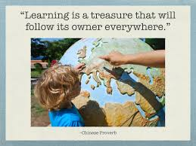
Our learning community is engaging students in experiences that require students to use thinking and communication skills, self-management and social skills, as well as research skills. The IB Primary Years Program (PYP) calls these: Approaches to Learning. These approaches are applicable across disciplines and grade levels and are evident when our learners begin achieving their goals.
We ask our learners to make connections, build explanations, consider viewpoints, and uncover complexities. Our learning community recognizes the importance of agency and action, as this is integral for any growth or change. “The PYP focuses on the development of the whole child as an inquirer, both in the classroom and in the world outside.” IBO.org
Through the IB Learner Profile, students, teachers, and parents can identify the characteristics that lead us to those deep learning moments. We practice these traits in all our learning.
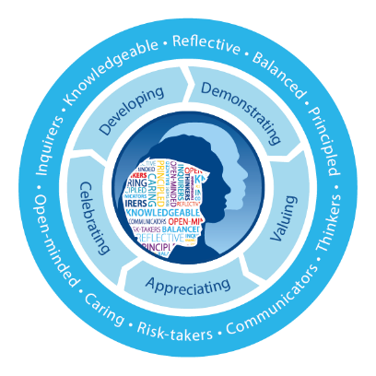

- We are knowledgeable and reflective
- We are principled and caring
- We are inquiring and communicators
- We are open-minded and thinkers
- We are risk-takers and balanced

By creating a culture of student agency, where importance is placed on the learner’s ability to have choice, voice, and ownership of their learning, Riffenburgh works to support every learner in their growth journey.

